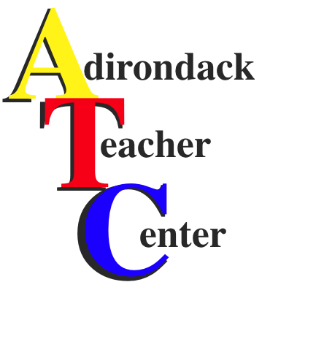
Technology Integration
Project Support

Area teachers are invited to embark on a hands-on adventure, integrating technology in their classrooms, with support from the Adirondack Teacher Center. Upon completion of the requirements for this project support, the hardware or software purchased will be yours to keep for the duration of your employment within your district. When your employment ends, the hardware or software becomes the property of the school district.

The project support will fund the purchase of hardware and/or software up to a maximum of $600.

Funding for these projects is limited, and applications are reviewed in the order they are received. However, applicants who successfully applied for a project support in the previous school year may be deprioritized in the event of multiple applicants. It is strongly suggested that you contact the ATC to find out if there are still project supports available for the current school year before you submit an application.

As a project support applicant, you will:
- Complete the application form included with this document. Use the checklist on the last page to ensure you have met all the requirements.
- Have a complete budget, and provide a full explanation of the source of any additional funds beyond the maximum amount of $600 covered by this project support.
- Obtain your building principal’s signature. This signature will be taken as proof that:
  - He or she is fully aware of the hardware and/or software you intend to purchase.
  - The hardware and/or software you are planning to acquire can and will be supported by your district’s technology infrastructure.
  - An approved plan is in place for any additional funds required beyond this project support.

As a project support winner, you will:
- Create a Learning Experience that integrates the hardware into the curriculum following the Learning Experience Guidelines found on the last page. This only needs to be done after being awarded the project support, not as part of the application.
- Provide a copy of that Learning Experience to the ATC.
- Implement the Learning Experience in your classroom.
- Provide a written evaluation of the hardware and/or software to the ATC.
- Demonstrate the use of the hardware or software to others. Suggestions for how this may be done include:
  - Holding a workshop for colleagues.
  - Demonstrating the technology and Learning Experience at a faculty meeting.
  - Presenting to the ATC’s Policy Board at one of their monthly meetings.

Be sure to follow all guidelines in the remainder of this application. If you have any questions, or need further assistance, please call the ATC at 518-483-7803 ext. 7168, or email us at AdirondackTC@gmail.com.
Learning Experience Format & Guidelines

Learning Context: Describe the purpose of the learning experience, including:
- The learning standard(s) and specific performance indicators from the standards documents on which the Learning Experience is based.
- A description of the relevance of this experience in the lives of the students beyond the classroom.
- What students need to know and/or be able to do to succeed with this experience.

Objectives: Using measurable goals, describe:
- The skills and/or concepts students will learn and demonstrate.

Procedures: Tell us about the lesson procedures, including:
- Steps and actions taken by the teacher.
- Steps and actions required of the students.
- Time frames for each part of the experience.

Instructional/Environmental Modifications: Describe the procedures used to accommodate the range of abilities and differing needs found in the classroom, including:
- Instructional modifications.
- Physical modifications made to the classroom setting.

Materials and Supplies: Identify the materials, supplies, and equipment needed to successfully complete this experience, including those for:
- The teacher.
- The students.

Assessments: Describe the:
- Tools and techniques used to gather and use formative assessment data in helping students meet the objectives of this experience.
- Tools and techniques used to gather summative assessment data in measuring student mastery of the objectives.

Reflection: Please respond to the following questions:
- In light of the implementation of this experience, did the integration of this technology in your classroom work as you had hoped? Explain.
- What are the implications of this experience for your classroom and student achievement?
- How do you plan to share the overall experience of integrating this technology with your colleagues?
- If you were going to take this integration further, what would you need?

Checklist

Before sending this application, please be sure you have:

- Typed the application (It should be grammatically correct, with no spelling errors, able to be easily reproduced, and with a legible font size.)
- Completely answered the questions on the application.
- Obtained the required signatures.

Submission of the application:

Send via USPS mail or BOCES courier to:
Adirondack Teacher Center
Franklin Academy High School, Room 169
42 Huskie Lane
Malone, NY 12953

Email the application as an attachment(s) to AdirondackTC@gmail.com
Please note, if submitting this way, you must scan and include the signature page, and then send the original, physical copy of the signature page to the ATC.

Adirondack Teacher Center
Technology Integration Project Support Application

Directions: Please complete this form as fully as possible. Please note that what distinguishes unsuccessful and successful applications is often the quality of thought and effort that has gone into the answers for the last three questions.

Applicant Name:
District:
Building:
Phone:
Address:
Email:

Name and manufacturer of the hardware and/or software to be purchased:

Cost (Please include a print copy - or PDF - of the shopping cart page of the vendor site or order form showing any applicable shipping fees, etc.):

What led to you choosing this particular piece of technology?

How do you envision this technology being used in your classroom?

How will the integration of this technology in your classroom benefit your students?

Technology Integration Project Support Application
Signature Page

In accepting this ATC project support, I understand that I will:
- Receive written notification if awarded the project support.
- Develop and implement a Learning Experience using the format included with this application. A copy of the Learning Experience will provided to the ATC no later than one full school semester after receiving the hardware and/or software.
- Provide a written evaluation of the technology to the ATC no later than one full school semester after receiving the hardware and/or software.
- Demonstrate the use of the technology as described on the first page of this application.
- Fulfill all of these requirements no later than one full school semester after receiving the hardware and/or software, and that if I do not, I will relinquish the technology to the ATC for redeployment.

__________________________________________________________________ _________________________
Signature of the Applicant Date

By signing this application, I affirm that:
- The proposal fits within the scope of our district/building’s educational goals.
- Our building’s technology infrastructure is capable of supporting the hardware and/or software.
- Provisions have been made for any costs for this project that exceed the $600 maximum of this award.

__________________________________________________________________ _________________________
Signature of the Building Principal Date

